A000-PAC-Poly-Nukuoro-Figure-Anthropomorphic-Wood-19th c

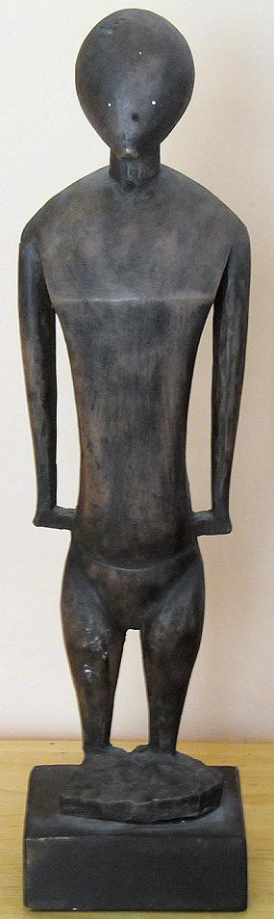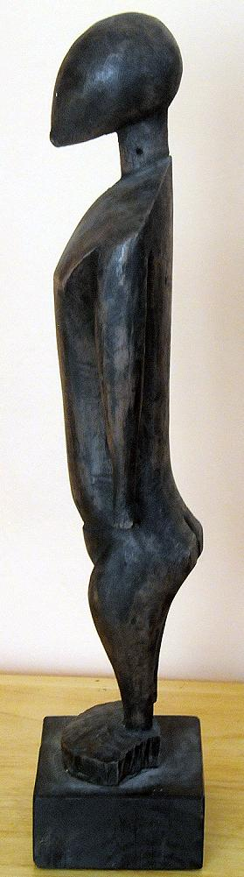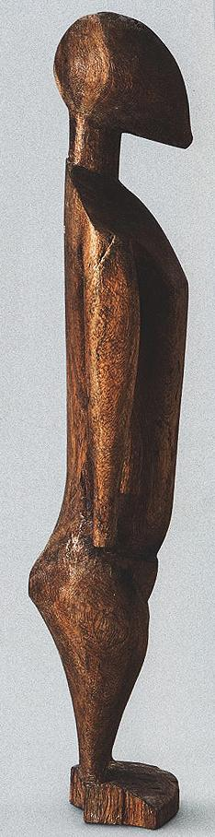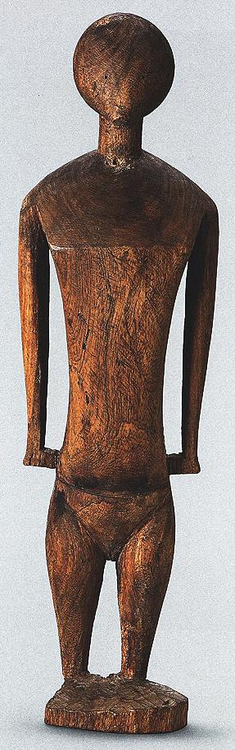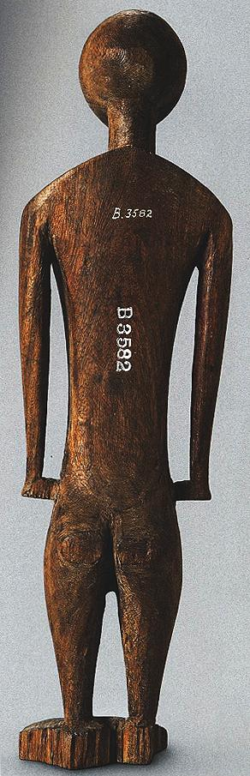

A B C D E

Fig. 1. A-B Left. Resin cast of the Nukuoro figure in the Bishop Museum (C-E), acc. No. 3582. Provenance: A-B, ex Bishop Museum, 1973.

Case No.: 13

**Accession No.**

**Formal Label:** PAC-Poly-Nukuoro-Figure-Anthropomorphic-Wood-19th c

**Display Description:**

## Nukuoro wooden *te tino aitu* figures.

Nukuoro atoll was settled in the eighth century CE, by Samoan migrants who voyaged in two canoes under chief Wawe, landed at Nukufetau in Tuvalu and then set sail for the uninhabited modu of Nukuoro atoll in Micronesia. This settlement of a Micronesian atoll by these Polynesians created a “Polynesian outlier”. The eighth century is important climatologically and socially, since favorable weather conditions during the seventh century had induced increasing populations on many Pacific islands making the incentive to migrate attractive to many as internecine strife ensued with the stresses of increasing populations.

Nukuoro immigrants brought their Polynesian Samoan language, Polynesian concepts of social hierarchy (ali’i) and genealogy, and their Polynesian aesthetic acumen that would inform the basis of a unique style of human figuration in banana fruit wood.

However, these Polynesians also incorporated Micronesian principles from Tuvalu such as small outrigger construction that was useful in an isolated atoll and banana-fiber loom-weaving which proved suitable for canoe sails as well as clothing for themselves and their deities.

## Nukuoro deities or ancestors were thought to inhere in animals, stones, pieces of wood or wooden figurines (*te* **tino aitu**) only for the period of the first fruit rituals, that took place towards the month of**Mataariki**, when the Pleiades are visible in the west at dusk. The rituals marked the beginning of the harvesting of two kinds of taro, breadfruit, arrowroot, banana, sugar cane, pandanus and coconuts. During the first fruit festivals the harvested fruits and food offerings were brought to the object in which the deities inhered, male and female dances were performed in honor of the bounty being offered and women were ceremoniously tattooed in expectation of successful childbirths. Those deified objects that now were in need of repair were renewed or replaced during these ceremonies.

The earliest of these breadfruit tree (Artocarpus altilis) figures were carved with clamshell (*Tridacna*) adzes, since basalt was not available on this atoll. Then, in 1830, Captain Benjamin Morrell (1795 – 1838 or 1839?) of the *Antarctic* landed on Nukuoro and traded iron tools for foodstuffs. Inhabitants were at first friendly but then aggressively sought to obtain more iron tools and attacked a landing party (Eilers 1934: 163). Iron tools that made wood carving easier than with clamshell adzes had induced a hitherto unknown behavior on the part of the Nukuoroans.

A trading post was established in 1870 and four years later the missionary Rev. E. T. Doane on board the *Star* reported “Idols carved from wood are common here, a very large one being in their temple.” (Doane 1874:205). The Godeffroy Museum in Hamburg, hearing of these figures, sent Johann Stanislaus Kubary as a special envoy to Nukuoro to collect specimens in 1873 and in 1877 (Kubary 1900:53). Kubary described how “The wood idols [*te*] *tino aitu* must from time to time be renewed, since many, especially those made from breadfruit, become decayed and collapse. Such old idols are called *wai soni* and are kept in the temples.” Each clan ensconced many figures of its particular deity in their places of worship (*amalau*).

In 1877, Kubary on his second visit purchased eleven figures that are now in German collections (De Grunne 1994). By 1885 most of the wooden sculptures had been either sold to collectors or destroyed by American protestant missionaries from the American Board of Commissioners for Foreign Missions (ABCFM) who had been assigned to the Marshall, Lukunor, Pohnpei, and Kosrae Islands’ The missionaries had earlier caused many religious images of Hawai’ian deities to be destroyed as a way of extirpating the devil.

By 1902 the advance of Christianity in Nukuoro was unexpected even to the missionaries. When the American Rev. Thomas Gray arrived to baptize a female chief he discovered that a large part of the population had already been partially Christianized by a Nukuoran woman who had lived on Pohnpei when the ABCFM missionaries were there. When Gray returned to the atoll in 1905, the sacred Nukuoro marae and its large temple had even been replaced by a church. By 1913, many Nukuoro traditions including religious figures, ceremonies, dances, songs, and stories had been either proscribed or destroyed. Today all of the extant Nukuoro wooden figures were made with iron tools as trade items: not one has survived from the pre-contact era made with shell.

**LC Classification:**

**Date or Time Horizon:**

**Geographical Area:**

**Map:**

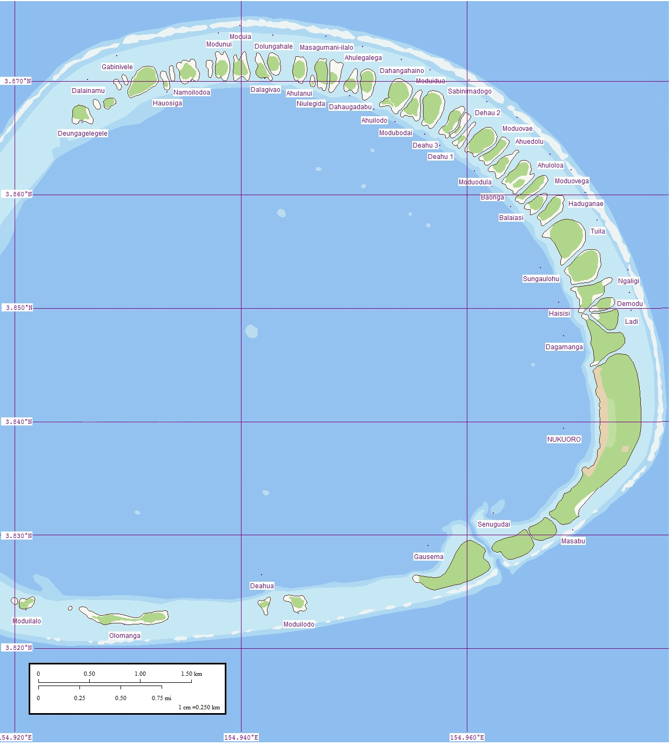

Fig.2 . Nukuoro Atoll, Caroline Islands, Micronesia. Map of eastern rim that contains islands. Western rim has no islands. . The lagoon averages 6 km (3.7 mi) in diameter. The image shows islets where the land surface is higher above sea level because the prevailing winds build up sand dunes. Coral in the lagoon appears as light blue patches. (This file was derived from: [Nukuoro North map.jpg](https://commons.wikimedia.org/wiki/File:Nukuoro_North_map.jpg):  [Nukuoro South map.jpg](https://commons.wikimedia.org/wiki/File:Nukuoro_South_map.jpg): )

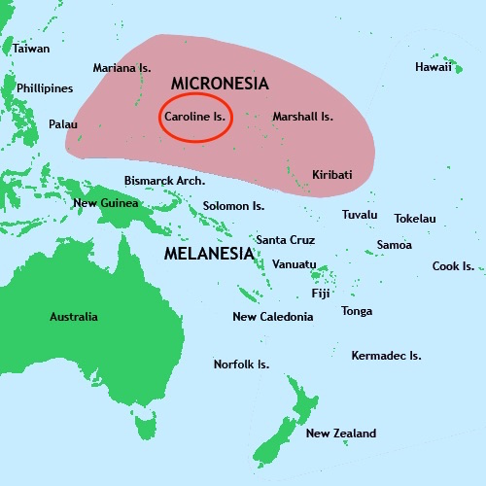

Fig. 3. Location of the Caroline Islands in which is Nukuoro Atoll.

Nukuoro Atoll (Ponape District, Trust Territory of the Pacific Islands) is a nearly circular atoll with a deep central lagoon and a fringing reef with forty-six small islets or *modu* (cf. Hawai’ian *motu*) that extend from the northwest clockwise to the southwest, which at low tide are interconnected.

**GPS coordinates:**

**Cultural Affiliation:**

**Media: wood**

**Dimensions:**

**Weight:**

**Condition:**

**Provenance:**

**Discussion:**

All the extant sculptures, ranging in size from 30 cm to 217 cm, have similar striking features: an ovoid head tapering slightly at the chin, a columnar neck, eyes as slits or not at all, sloping shoulders and a chest indicated by a simple line. Some female figures have rudimentary breasts. Some of the sculptures, be they male, female or of indeterminate sex, have a rudimentary indication of hands and feet. Buttocks are always flattened and set on a flexed pair of legs.

**References:**

## De Grunne, B. 1994. “Beauty in Abstraction: the Barbier-Mueller Nukuoro Statue”. *Art Tribal*, Geneva: 25-40.

## Doane, E.T. 1874. The Caroline Islands (Cruise of the Star). The *Geographical Magazi*ne, 1:203-205.

## D’Urville , M.J. Dumont. 1843. *Voyage au Pole Sud et dans L’Oceanie sur les Corvettes L’Astrolabe et la Zelee*. Vol. V. Paris, Gide et Cie.

## Eilers, A. 1934. “Inseln um Ponape”. *Ergebnisse der Sudsee-Expedition 1908–1910*. IIB Vol. 8. Hamburg, Friederichsen de Gruyter.

## Hezel, Fr. Francis X. S.J. 1979. http://www.micsem.org/pubs/articles/historical/forships/pohnpei.htm .

Kaeppler, Adrienne L. 2008. The Pacific Arts of Polynesia & Micronesia .Oxford: Oxford University Press.

Kaufmann, Christian, Oliver Wick (eds.). 2013. Nukuoro. Sculptures from Micronesia. Basel: Fondation Beyeler, Hirmer.

## Kubary, J. 1900. “Beitrag sur Kenntnis der Nukuoro- oder Monteverde Inseln”. *Mitteilungen der Geographischen Gesellschaft in Hamburg*, XVI.

## Morrell, Benjamin. 1832. **A Narrative of Four Voyages to the South Sea, North and South Pacific " Ocean, Chinese Sea, Ethiopic and Southern At/antic Ocean, Indian and Antarctic Ocean, from the Year 1822 to 1831**. New York, J. & J. Harper.

Sharp, Andrew. 1960: The Discovery of the Pacific Islands. Oxford: Clarendon Press.

## Volprecht, K. 1968. “Nukuoro: Zur Sammlung Kapitan Jesche im Rautenstrauch-Joest-Museum.” *Ethnologica* (NF) Band 4: 532-542.

Ward, R. Gerard, ed. 1967. American Activities in the Central Pacific 1790-1870.8 Vols. Ridgewood, NJ, The Gregg Press.